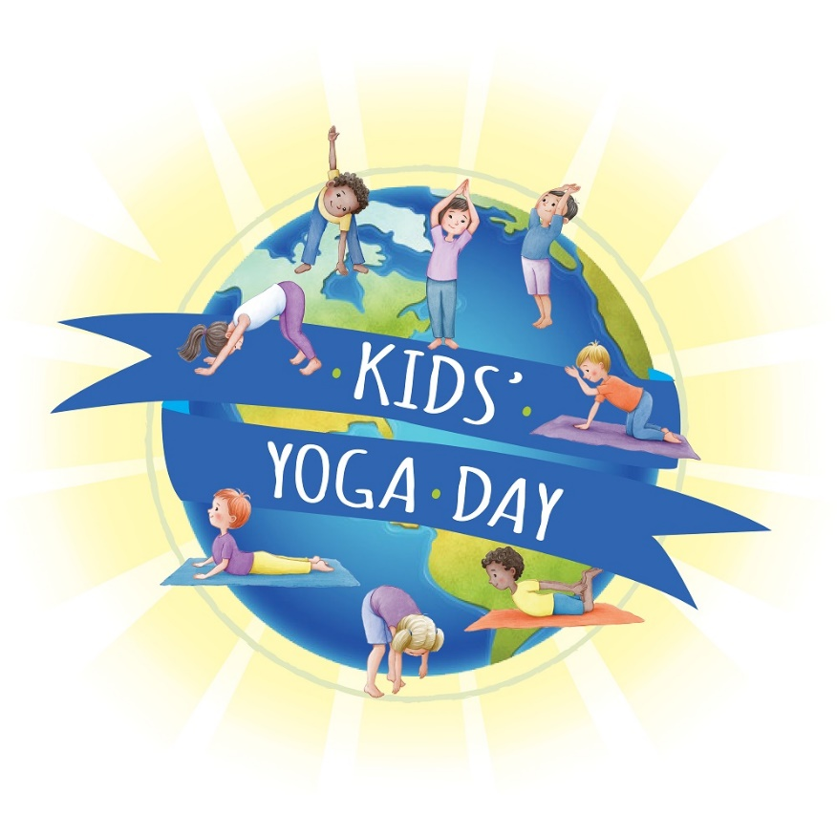
Yoga is: ___________________________________________
Yoga makes me feel: ________________________________
I recommend yoga at school because: ____________________
_______________________________________________________
I live in this country: _____________________________________
This is me in my favorite pose:

